**Advanced Software Engineering CS5551 Lab 2**

In this assignment I have tried to develop an application which compares the routes of car , bus and walk between our UMKC campus and Kansas City Airport.

The interface was developed using jquery mobile, HTML, CSS styles taking the using online hosted CDN links of Jquery mobile and Jquery. The service part was developed from google map services which includes the direction service from google as learnt from tutorial 3. A simple interface was developed which shows three buttons on clicking which directly the routes to the corresponding mode of transportation is displayed using google maps.

The application was tested both on a desktop browser and a mobile emulator(opera) as shown in the screenshots below.

**Application on Desktop:**

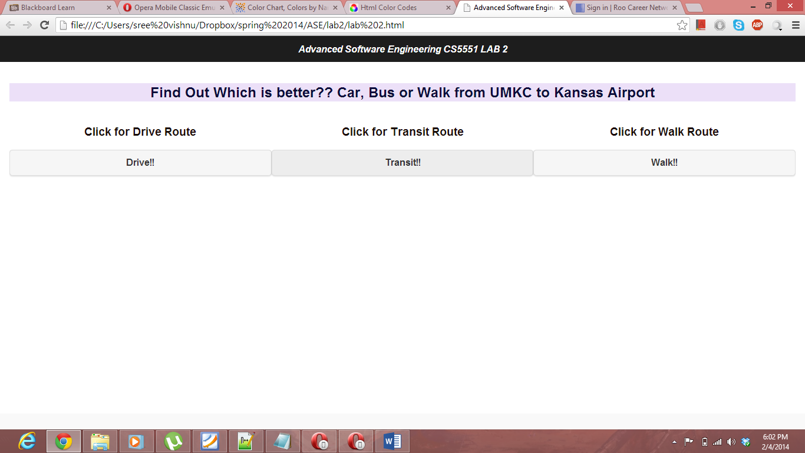

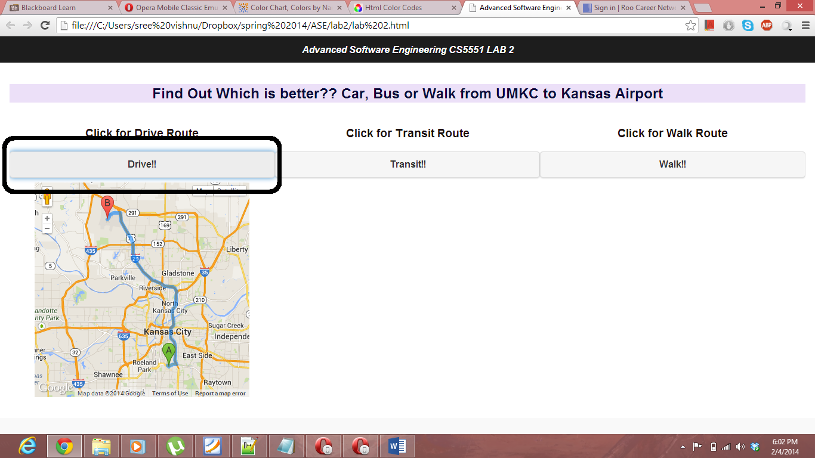

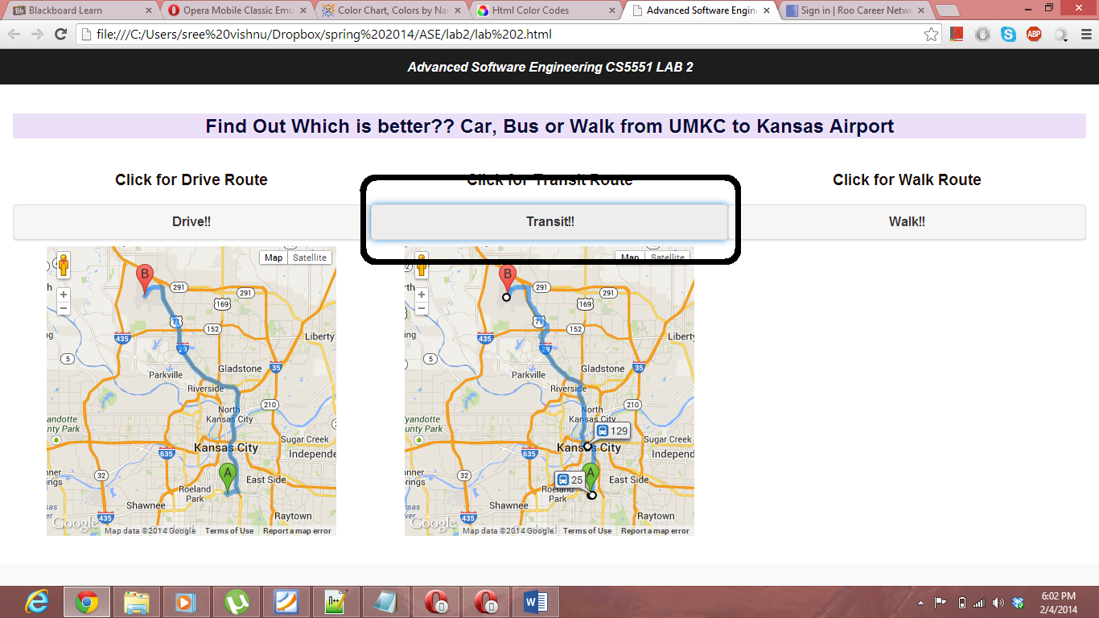

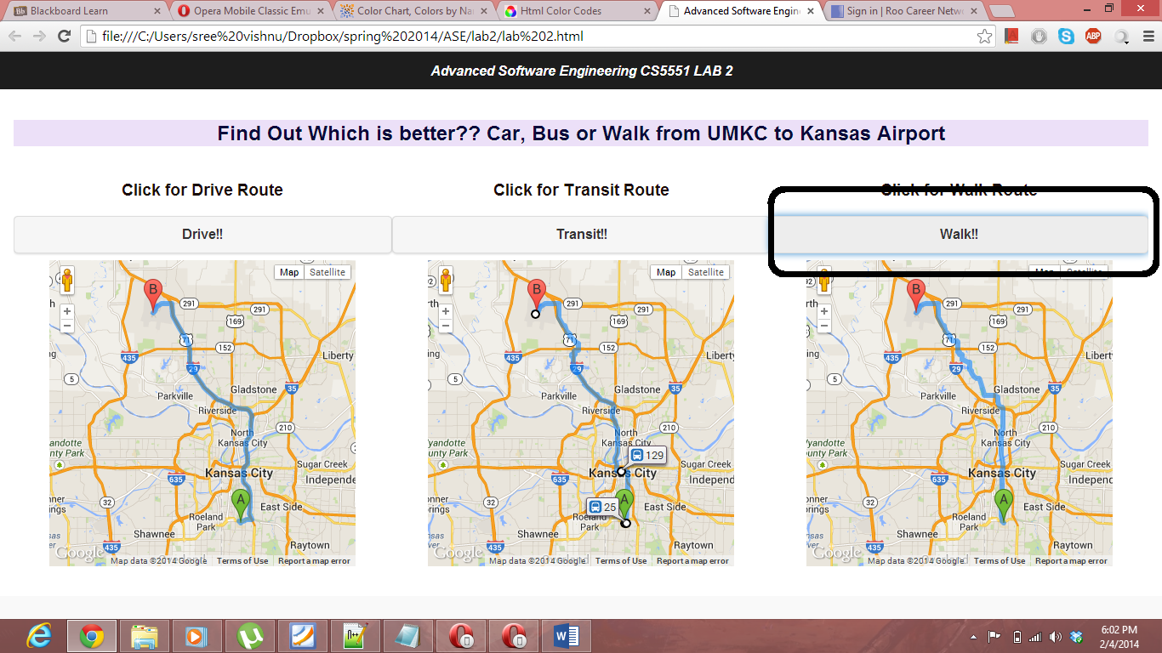

**Applications on Mobile Emulator:**



